BABALWA MPUNYUKA – Practical Activity 5

[Babalwa.mpunyuka@womentechsters.com](mailto:Babalwa.mpunyuka@womentechsters.com)

1. I have added one Headquarter named CarMaxHeadquarters and 2 Sales locations named SalesLocation1 and SalesLocation2. The various departments were also created.

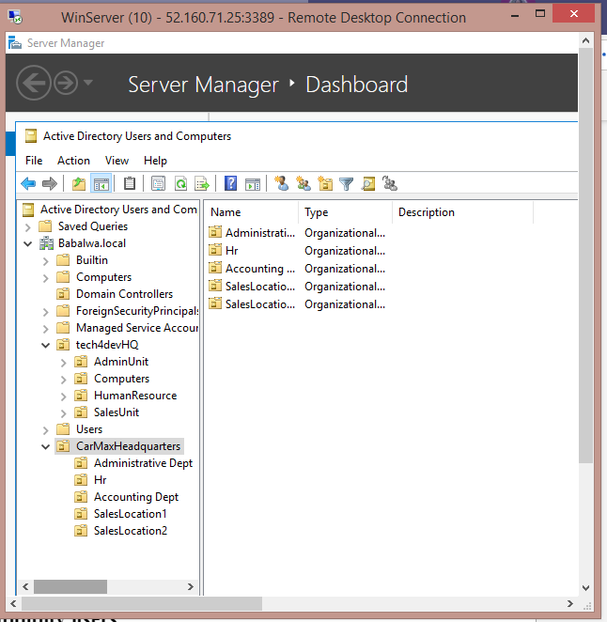

1. I have created users and assigned them to their different groups.

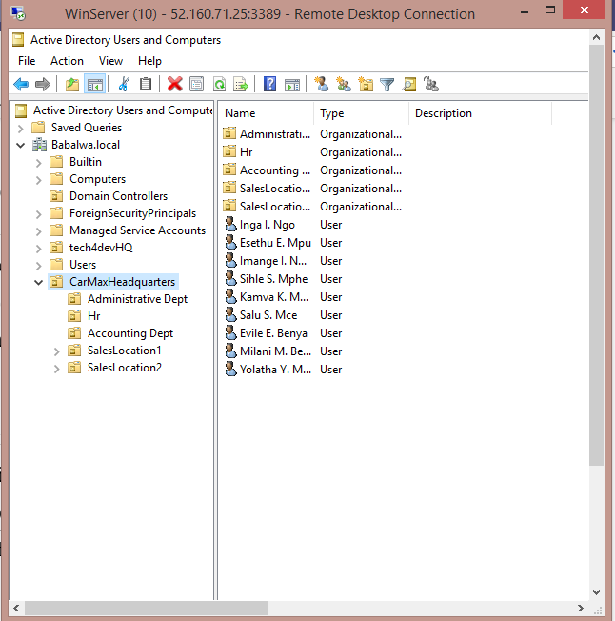

1. 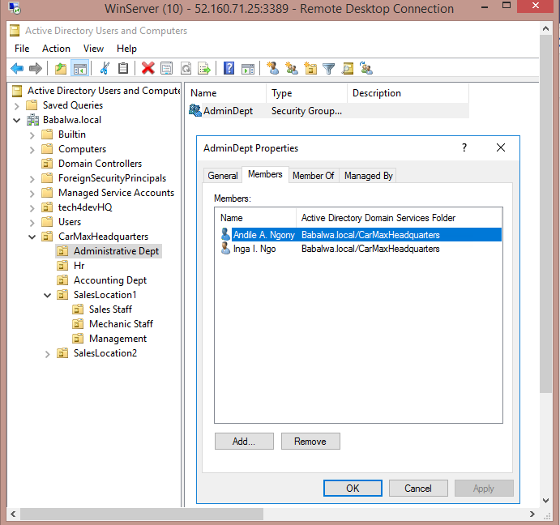I had added a user name Andile to the SalesLocation1 unit and I promoted the user to the Administrative Dept unit.

However the user is still active in the Sales Staff department.

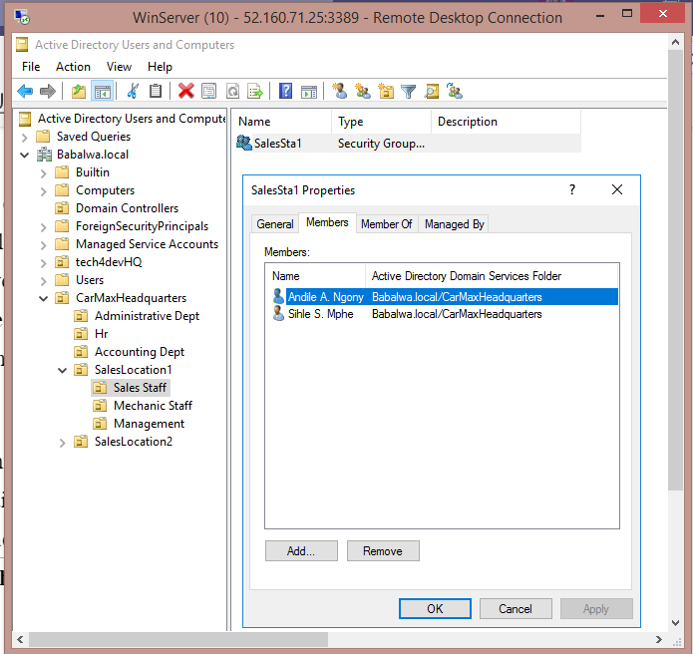

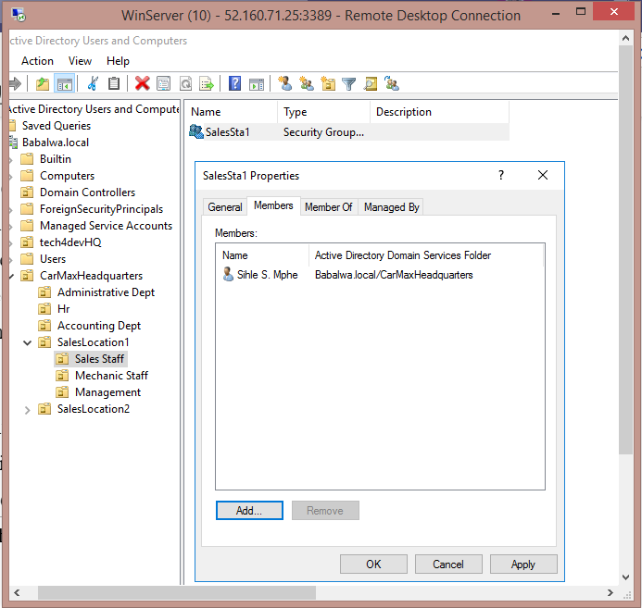I then removed the user that has been promoted to the Administrative Dept so that they do not inherit the priviledges of the Sales Staff.

1. The user that is being disabled is in the Mechanic Staff. The account is disabled for a period of 30 days to prevent auauthorized from using the account.

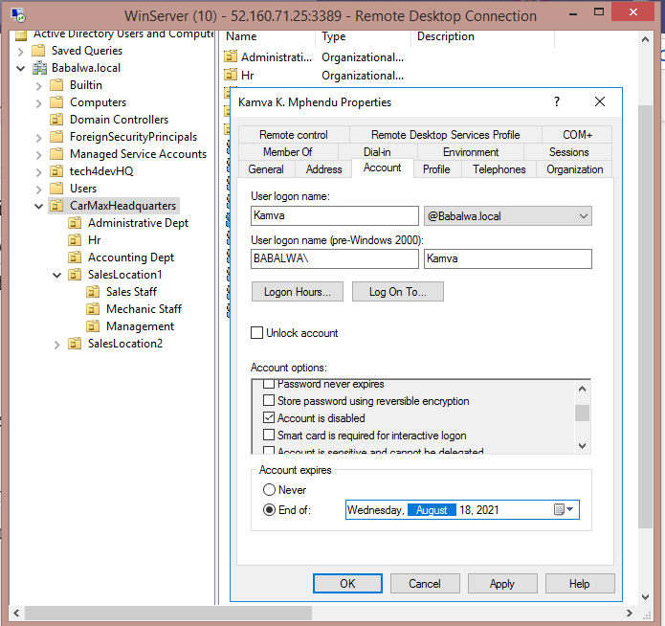

1. 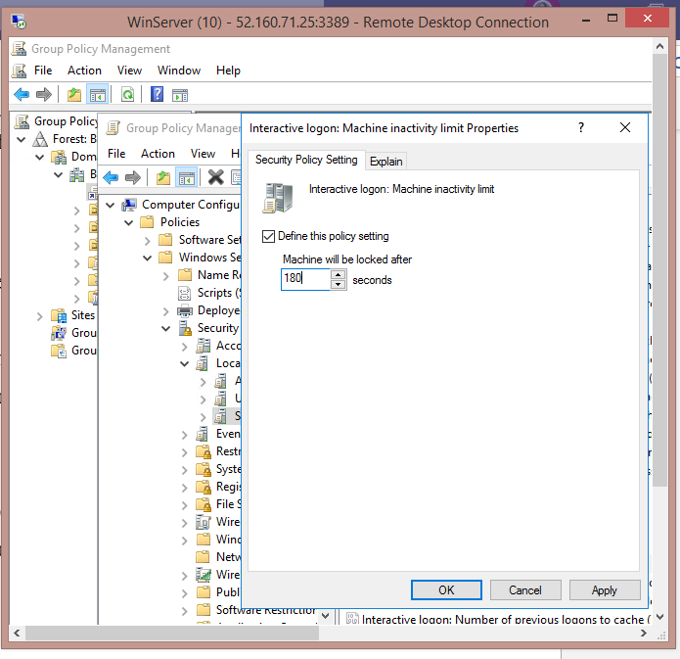I have added a computer policy under Accounting Dept to ensure all computers are locked or disabled after 3 minutes of inactivity.

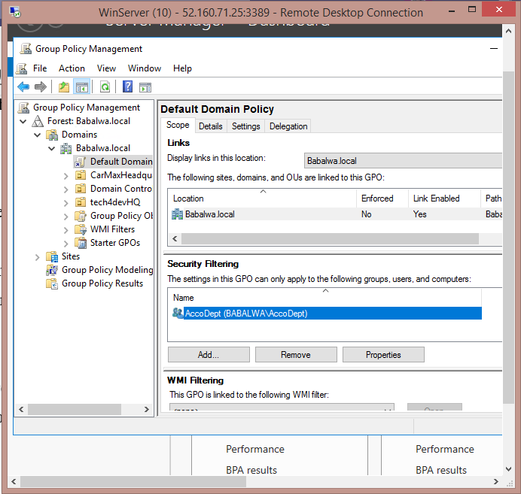The policy created applies only to the Accounting Department users.